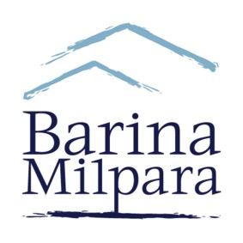

ABN 15 001 401 403

Mr Nick Park

Crowe Horwath

Level 15

1 O’Connell Street

Sydney NSW 2000

**BARINA MILPARA LODGE LTD – BOARD NOMINATION FORM**

A shareholder may nominate or be nominated by another shareholder for election to the office of Director of Barina Milpara Lodge Limited.

NOMINEE DETAILS

Name

Address

Phone

Nominator

Date